PARENT/SCHOLAR HANDBOOK

2023-2024

Non-Discrimination Statement: The Washoe County School District is committed to nondiscrimination
on the basis of race, color, national origin or ethnic group identification, marital status, ancestry, sex,
sexual orientation, gender identity or expression, genetic information, religion, age, mental or physical
disability, military or veteran’s status in educational programs or activities, and employment as
required by applicable federal and state laws and regulations. No District employee, including, without
limitation, administrators, faculty, or other staff members, nor scholars shall engage in acts of bullying,
harassment, or discrimination on the premises of any public school, school-sponsored event, or school
bus in the District. Prohibited behaviors include cyber-bullying, sexual harassment, hazing,
intimidation and retaliation.
***********
Disclaimer: This Parent-Scholar Handbook contains references to Board Policies and other documents
pertaining to the rules and regulations of the Washoe County School District. The District reserves the
right to revise any of these documents during the course of the school year. For the current version of
any of these documents, please check the District’s website at www.washoeschools.net/Policy.
_____________________________________________________________________________________
Declaración de No Discriminación: El Distrito Escolar del Condado del condado de Washoe se ha
comprometido a no discriminar en base a raza, color, origen nacional o grupo étnico, estado civil,
ascendencia, sexo, orientación sexual, identidad o expresión de género, información genética, religión,
edad, discapacidad mental o física, militar o condición de veterano en programas o actividades
educativas y de empleo como requerido por las leyes y reglamentos federales y estatales aplicables.
Ningún empleado del Distrito, incluyendo, sin limitación, los administradores, profesores u otros
miembros del personal, ni los estudiantes no deberán participar en los actos de intimidación, acoso o
discriminación en las instalaciones de cualquier escuela pública, evento patrocinado por la escuela o
autobús escolar en el Distrito. Conductas prohibidas incluyen el acoso cibernético, acoso sexual,
hostigamiento, intimidación y represalias.
***********
Negación de responsabilidad: Este Manual para Padres y Estudiantes contiene Políticas del Consejo Directivo y Administrativo y otros documentos relativos a las normas y reglamentos del Distrito Escolar del Condado de Washoe. El Distrito se reserva el derecho de modificar cualquiera de estos documentos en el transcurso del año escolar. Para la versión actual de cualquiera de estos documentos, por favor revise la página web del Distrito en www.washoeschools.net/Page/2903.
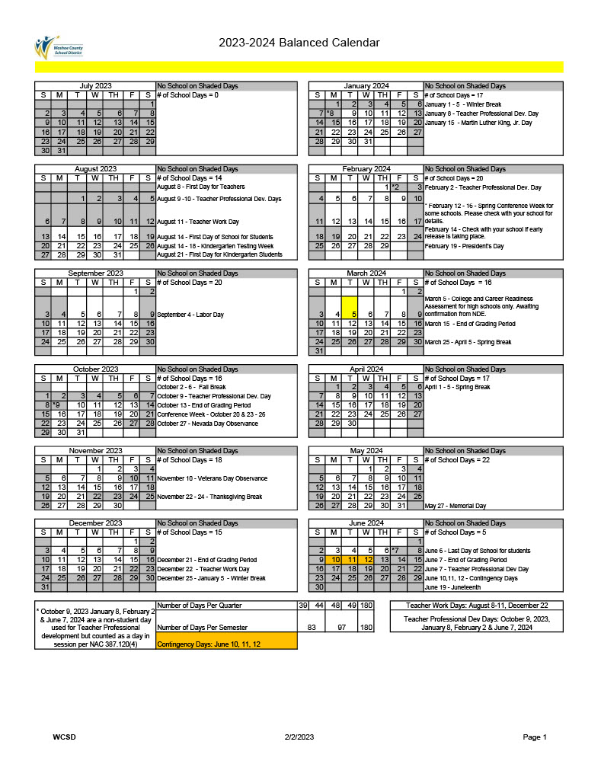
TABLE OF CONTENTS

Letter from the Principal p. 5
School’s Vision and Mission Statements p. 6
Bell Schedule p. 6
Academic Integrity p. 7
Accidents p. 7
Academic Letter p. 7
Academic Warnings p. 7
Advertising p. 7
Athletic Eligibility Requirements p. 9
Clubs and Activities p. 9
Drop Dates p. 9
Grades p. 9
Grading and Report Cards p. 9
Homework p. 9
Homework Request p. 10
Incompletes p. 10
Make-up Work p. 10
Scholars Entering Late p. 10
Withdrawal Grades p. 11
Attendance p. 11
Release of Students During the School Day p. 11
Confirmed Truant Policy p. 12
Off-Campus Pass p. 12
Tardy Policy p. 12
Behavior p. 12
Bullying/Harassment/Threats p. 13
Gender Identity p. 13
Cell Phones and Other Devices p. 14
Responsible Use and Internet Safety p. 14
Dances p. 14
Dance/Guest Pass Guidelines p. 14
Dress Code p. 15
Dress Code Consequences p. 15
Graffiti p. 15
Hall Passes p. 15
Loitering p. 15
Lunch Time p. 16
School Police p. 16
Searches of Scholars p. 16
Senior Prank p. 18
Service Animals p. 18
Sexual Harassment/Intimidation p. 18
Skateboarding p. 19
Smoking and Tobacco p. 19
Suspension p. 20
Special Conditions of Suspension p. 20
Property p. 20
Parking Lot p. 20
Graduation Guide p. 21
College and Career Ready Diploma p. 22
Messages or Emergencies p. 23
Parent Complaint p. 23
Scholar Records—Parent and Scholar Rights p. 23
Release of Information about Scholars p. 23
Transcripts and Records Requests p. 23
Visitor Passes p. 24
Transportation of Scholars p. 24

Dear Scholars,
Welcome to the 2023-2024 school year at Innovations High School. I am very pleased to welcome all of you to our Innovations learning community. I am excited to begin the school year as it is always a time of great hope and possibility. Each scholar has the opportunity to walk a path of personal growth and academic progress. If you have been doing so in recent years, please work to continue on your path. If you aspire to make changes that will lead to further growth, you will have great opportunities to work closely with your advisors to refocus on school. This may look like employing new and better strategies to complete your school work or to stay focused on classroom tasks. Remember that your success contributes to the success of our whole community—as do your actions and choices that lead to success.
Perhaps most importantly, we can all attend our classes regularly. As a famous film director once stated, “90% of success is showing up.” We need to attend school every day and we need to engage in our classes. If each of you simply do these two things, we will continue to grow our fantastic learning community.
At Innovations High School, we value the holistic growth of every scholar. This means we seek to engage all scholars in enriching academic experiences while in a positive, pro-social and affirming school environment. Cultivating such a nurturing community is the responsibility of all our community members. We all need to discipline ourselves to acting out of kindness toward one another and to being accepting of one another. As we do this, we will enrich our school culture.
The policies and procedures contained in this handbook are the result of a great effort on the part of the administration, faculty, and scholars. This information has been carefully prepared and will be of great value in helping you adjust to our school and to becoming an integral part of it.

Sincerely,

Michael Bradley
Principal

INNOVATIONS HIGH SCHOOL

Mission Statement:
At Innovations High School, we nurture scholars’ passion for learning by engaging them in meaningful, relevant, community-based lessons through which they explore themes of social justice and advocacy to discover their own agency and voice. We are committed to engaging our scholars as whole human beings who will become powerful citizens of the world.

Vision Statement:
At Innovations High School, we foster and develop life-long learners through authentic, community-based practice that celebrate diversity and individuality.

Daily Class Schedule
Class | Monday | Tuesday | Wednesday | Thursday | Friday
Zero Period | 7:30am-8:27am | 7:30am-8:27am |  | 7:30am-8:27am | 7:30am-8:27am
Kick In | 8:30am-8:50am
First Period | 8:55am-9:52am | 8:30am-9:30am |  | 8:30am-9:30am | 8:30am-9:23pm
Second Period | 9:55am-10:52am | 9:35am-10:35am |  | 9:35am-10:35am | 9:25am-10:22am
Advisory | 10:55am-11:30am | 10:40am-11:15am | 8:30am-11:10am
Literacy To Action |  |  | 11:40am-2:20pm | 10:40am-11:15am | 10:25am-10:55am
LUNCH | 11:30am-12:00pm | 11:15am-11:45pm | 11:10am-11:40am | 11:15am-11:45pm | 10:55am-11:25am
Third Period | 12:00pm-12:57pm | 11:45am-12:45pm |  | 11:45am-12:45pm | 11:25am-12:23am
Fourth Period | 1:00pm-1:57pm | 12:50pm-1:50pm |  | 12:50pm-1:50pm | 12:25pm-1:23pm
Fifth Period | 2:00pm-2:57pm | 1:55pm-2:57pm |  | 1:55pm-2:57pm | 1:25pm-2:23pm
Kick Out |  |  |  |  | 2:23pm-2:57pm
Sixth Period | 3:00pm-3:57pm | 3:00pm-3:57pm |  | 3:00pm-3:57pm | 3:00pm-3:57pm

ACADEMIC INTEGRITY
Plagiarism occurs when a scholar uses another’s work without giving credit to the source. Learning to avoid plagiarism is a skill that scholars should master. Plagiarism of copyrighted material is against federal laws and school district policy. Plagiarism typically occurs in school situations the following ways: 1) a scholar uses another’s words without using quotation marks around the material, 2) a scholar uses another author’s ideas or information without giving credit for the material (citing the source), 3) a scholar does both use the author’s words and ideas without citing the source.
Cheating is defined by but not limited to: 1) copying someone else’s homework, class work, or test answers, 2) allowing someone else to copy one’s work or test answers; using any kind of unauthorized device, study aid, or cheat sheet 3) possessing or viewing a copy of an exam beforehand, 4) sharing test information with scholars who have not taken the test, 5) changing one’s answers or someone else’s when correcting in class.
Consequences for violations of the policy could include no credit on the assignment in which plagiarism occurred and/or possibly no credit for the course. Additional consequences per the school’s/district’s progressive discipline policy may apply. For details pertaining to the WCSD Plagiarism and Cheating policy please visit: https://www.wcsdpolicy.net/pdf_files/6642%20AP%20-%20Plagiarism%20and%20Cheating%20v3.pdf

ACCIDENTS
Scholars, who are injured at school, are responsible for reporting the accident to their advisor and/or clinical aide, to get first aid treatment and obtain an accident/injury form. The clinical aide is responsible for completing the accident form and reporting the accident to the Principal or designee. The parent, guardian or other responsible adult will be notified and take responsibility for the ill or injured scholar leaving school.
ACADEMIC LETTER
Innovations High School rewards the scholar who maintains a 3.7 or better academic GPA for four high school semesters at Innovations; the semesters need not be consecutive. (The scholar must be enrolled in at least the minimum academic load.) Cumulative GPA and citizenship grades are not considered. For each additional semester of a qualifying GPA, a bar is earned.
ACADEMIC WARNINGS
When a scholar is not making satisfactory progress in school, the advisor shall prepare a notice that informs the scholar that he/she/they is in danger of failing. Unsatisfactory progress is defined as a level of achievement leading to a failing grade or work that would cause a grade to deteriorate two full grades below previous performance. (Example: A scholar who received an “A” on the grade report and now is doing “C” work would require a notification.) The scholar will prepare failure notices at the end of the fourth week of the grading period each academic quarter.
ADVERTISING
Scholars, who wish to display posters, place announcements on bulletin boards, or engage in any other form of advertising in or about the school, must secure the approval from the Principal or Principal’s designee. No permission will be granted for the advertising of any outside activity. No announcement or notices of a commercial venture based on the motive of profit shall be placed in the school.
ATHLETIC ELIGIBILITY REQUIREMENTS
Scholars wishing to participate in athletics may do so at their zoned schools. Please contact the zoned school for additional information. For more detailed information about our WCSD District Recognized Athletics Policy, please link to: https://www.wcsdpolicy.net/pdf_files/board_policy/5325-Policy-Rec_Athletics-v2_FINAL.pdf
CLUBS AND ACTIVITIES
Scholars wishing to create an after school club will need to secure permission from the Principal. Minimal requirements include supervisory staff.
Please note that school rules apply when students are engaging in extracurricular school activities. For more detailed information about our WCSD School Activities Policy, please link to: https://www.wcsdpolicy.net/pdf_files/board_policy/5300-Policy-Activities-v2.1_Final.pdf
DROP DATES
Scholars may not drop a course/enroll in a different course after the 20th day of the start of a semester. In this case, a W/F could be issued. Exceptions would be with the approval of the Principal.
GRADES
The state mandated grading system for all classes, grades 9-12, will incorporate the letter designation: A; B; C; D; F, and INC.
For the purpose of computing grade point average, the letter grades will be transposed to the standard 4.0 scale; A (100- 90%)=4.0; B (89-80%)=3.0; C (79-70%)=2.0; D (69-60%)=1.0; F (below 60%) =0. Honors courses will have a 0.025 “value added” and Advanced Placement courses will have a 0.050 “value added”. The grades S and U may be used in special classes and will not be included in the computation of the grade point average. Subjects granting only ¼ credits are not computed for grade point average.
GRADING AND REPORT CARDS
Reports notifying parents/guardians of their scholar’s progress in school are issued quarterly to each scholar who has been enrolled four or more weeks during the grading period. The responsibility for determining the grade rests with the classroom advisor. All grade reporting will be done on approved forms. The report will be distributed following the close of the grading period.
HOMEWORK
Homework plays an important role in the learning process. Conventional purposes for homework are practice, preparation, check for understanding, and development of work habits. Homework is one of many learning activities to engage scholars.
Homework should: extend learning and/or provide practice in applying concepts initially presented in the classroom; provide opportunities for independent work; strengthen concept and skill development; and provide opportunities for enrichment.
HOMEWORK REQUEST
If it is anticipated that a scholar will be absent for a period of at least three days, homework requests should be processed through the Attendance Office or call 775-333-5150. The parent/guardian should make such a request at least 24 hours prior to the time the homework assignments are to be picked up and assignments will be held in the main office, unless alternative arrangements are requested. If you are inquiring about homework assignments that need to be picked up, please call the Attendance Office at 775-333-5150.
For more detailed information about our WCSD Homework Policy, please link to: https://www.wcsdpolicy.net/pdf_files/board_policy/5300-Policy-Activities-v2_Final.pdf
INCOMPLETES (INC)
Scholars who do not complete the work required for completion of a course of instruction may receive an incomplete (INC). Scholars receiving an incomplete have three weeks from the date of issuance of the report card to make up the work. An incomplete in the spring semester must be made up by the end of the third week in the fall semester. It is the scholar’s obligation to make contact with the advisor to receive the assignment/s necessary to remove the incomplete grade. The advisor who posted the incomplete grade must provide the grade assignments that are to be completed within the prescribed three-week period. If the work is not made up, the incomplete becomes an “F” and the scholar receives no credit for the class.
MAKE-UP WORK
Parents are reminded that scholars must request make-up work on the day the scholar returns to class. Failure to request the make-up work on the day the scholar returns to class may result in the loss of the opportunity to make-up the work.
Within two (2) days of receiving the request, the advisory will prepare the requested make-up work. However, not all work can be made-up. Work that is participatory in nature (labs, guest speakers, class discussions) can be made up at the discretion of the advisor. The scholar must return the completed make-up work within the designated deadline.
The scholar has the number of days he/she/they was absent plus one day, from the day the work was picked up, to return make-up assignments. Please be aware that many advisors post homework assignments on Infinite Campus and/or Teams, which may save both you and the advisor time.
SCHOLARS ENTERING LATE
During the first four (4) weeks of the semester, a high school scholar may enter classes with the intent of earning credit and be allowed to make-up missed work solely at the discretion of the individual advisor. For that scholar who has not been enrolled in or attending any educational program that desires to enter a Washoe County School District high school after the fourth week of the semester, the scholar will NOT earn credit. The scholar may be enrolled for audit, may be counseled about registration for appropriate correspondence course(s), or may petition for entrance into an alternative learning center if enrollments are still possible into one of their learning centers. In the case of a scholar who has not been enrolled in or attending any educational program that desires to enter a WCSD high school extremely late in the semester, that scholar should be registered for classes at the beginning of the following semester.
WITHDRAWAL GRADES
A scholar withdrawing from the class prior to the completion of the course requirements will receive no credit for the class.
A scholar withdrawing from school without transferring will receive a “W” and no credit. Scholars transferring to another school will receive a grade showing progress to date and no credit. If a scholar drops a class after eleven weeks, he/she will receive a failing grade at the end of the semester.
ATTENDANCE
A scholar shall not be absent from school 10% or more of school days in order to be promoted to the next grade or 10% or more of class periods for a scholar to earn credit in a class, as applicable. Scholars who are absent for any reason who miss 10% or more of school days will be labeled Chronically Absent.
A note or phone call must be received from the parent/guardian by the office within 3 days of the initial absence to avoid an unverified absence.
All absences, with the exception of the following attendance codes, count towards the 10% chronically Absent.
- EMI/SCH = School Related Absences (Testing, In the Office, etc.)
- MVE= McKinney-Vento Eligible (Child in Transition)
- HDE/HDED=School Medical Exclusions
- EMD=Healthcare (Medical Professional Note Required)
*It is Parent/Guardian’s responsibility to check Infinite Campus to make sure attendance is accurate and to make sure make-up work is completed and returned to the school. It is the scholar’s responsibility to request make-up work from the advisor on the day the scholar returns from an absence. It is the Advisor’s responsibility to provide make-up work within 2 days to the scholar upon the scholar’s request. Scholars have the number of days absent plus one beginning the day that the advisor provided the make-up work to complete and return the make-up work to the advisor.
For more detailed information about our WCSD Attendance Policy, please link to: https://www.wcsdpolicy.net/pdf_files/board_policy/5400_Policy-Student_Attendance_v5_Final.pdf
RELEASE OF STUDENTS DURING THE SCHOOL DAY
Per district policy, students can only be removed from school by parents or guardians with whom they reside based on our school records. Other relatives cannot remove a student from school.
Also, police can remove a student if:
- They possess a court order,
- They possess a warrant for a student’s arrest, or
- They are arresting the student.
For more detailed information about our WCSD Removing a Student During the School Day Policy, please link to: https://www.wcsdpolicy.net/pdf_files/5146%20Reg%20-%20Release%20of%20Students.pdf
CONFIRMED TRUANT POLICY
When a scholar is verified to have left campus or the scholar’s whereabout are unknown following being on campus earlier in the day, the scholar’s attendance will be marked confirmed truant. After the 1st time, the scholar will receive their 1st truancy letter, and truancy, the counselor, and the parents will be notified. The scholar will be retaught expectations. The scholar’s attendance will be monitored by their counselor and the attendance office.
When a scholar is confirmed truant a 2nd time, truancy, the scholar’s counselor, and parents will be notified. A 2nd truancy letter will be sent home and the scholar will sign a contract and be formally placed on a 20-day attendance monitor. The scholar’s attendance will be monitored by their counselor and attendance.
When a scholar receives a 3rd confirmed truancy, the paperwork will be filled out to send the scholar to the Scholar Attendance Review Board (SARB), where the parents and scholar will need to meet with the board to determine why the scholar is not attending school regularly and what, if any supports need to be put in place for the scholar to help them to successfully attend school. For an 11th or 12th grade scholar who receives a 3rd truancy letter, paperwork will be completed to have the scholar cited for not attending school. This citation will result in the scholar possibly having to go to court to determine a consequence for not going to school.
OFF CAMPUS PASS
If a scholar needs to leave campus for an appointment, he/she/they must obtain an off-campus pass from the attendance office or an administrator. This pass will only be issued with authorization from a parent or guardian and will need to be shown to the attendance office upon departure (and return, if the scholar returns to school the same day).
TARDY POLICY
Scholars are expected to be in classes on time. Scholars who are not in assigned spaces on time may fall under policies for truancy.
BEHAVIOR
All Washoe County School District rules and guidelines as stated on the school district website at www.washoeschools.net will be followed by Innovations High School.
At Innovations, we believe in individualized positive behavioral supports and restorative practices to achieve both social and academic success while preventing problem behavior.
Innovations High School works closely with School Police, Safe Voice, and Secret Witness.
We have Zero Tolerance at Innovations High School for Weapons, Fighting, Drugs-Alcohol, Gang Activity, Bullying.
Scholars can be suspended, cited, and/or arrested for participating in zero tolerance activities.
One of the goals at Innovations High School is to provide a safe learning environment for both scholars and staff. We are successful in achieving this when scholars, parents, and staff work together. The administration seeks to take a very proactive approach in solving problems in an appropriate manner. Please speak with any administrator if you are concerned about any issue related to the safe and appropriate learning environment at Innovations High School.
Please make sure you are aware of and understand the rules and policies of not just Innovations High School, but also of WCSD.
BULLYING/HARASSMENT/THREATS
If you are a victim of bullying/harassment and/or threats, report it to counseling or administration immediately.
Scholars and parents can also report as a Secret Witness by calling 329-6666 or text 274637 enter TIP725 + message or going to the website www.secretwitness.com or at www.wcsdbullying.com
Safevoice is another option. You can call Safevoice at (883) 216-7233 or submit a report online at Safevoicenv.org.
Quite often these issues can be solved through conflict/resolution. We initiate this proactively in lieu of fighting or verbal confrontations.
For more detailed information about our WCSD Bullying Policy, please link to: https://www.wcsdpolicy.net/pdf_files/administrative_regulations/5701-Reg-Student_Bullying-v4.2_FINAL.pdf
At Innovations High School, we strive to create a safe and respectful learning environment for all scholars. This requires respect for all members of our learning community and the affirmation and celebration of all individuals in our community. For more detailed information about our WCSD Safe and Respectful Schools Policy, please link to: https://www.wcsdpolicy.net/pdf_files/board_policy/5700_Policy-SRLE-v6_FINAL.pdf
For more detailed information about WCSD Student Behavior Manual, please link to: https://www.wcsdpolicy.net/pdf_files/board_policy/5100_Policy-Student_Behavior-v7_Final.pdf
GENDER IDENTITY
At Innovations High School, we strive to recognize, affirm and celebrate all of our scholars for who they are. We give all scholars respect and reinforce their dignity as human beings. This unconditional acceptance of all community members extends to the gender identities of our scholars. We embrace who they are and strengthen their collective efficacy.
For more detailed information about our WCSD Gender Identity Policy, please link to: https://www.wcsdpolicy.net/pdf_files/administrative_regulations/5161_Reg-Gender_Identify-v2.pdf
CELL PHONES AND OTHER DEVICES
Cell phones, headphones and other electronic devices can be disruptive and interfere with scholar learning, including the learning of those that are not in possession of such devices. We encourage that cell phones be turned off while in the classroom. The use of cell phones, however, is up to individual classroom advisor’s discretion.
Cell phones and smart devices during assessments (classroom and standardized/state) are strictly prohibited. Scholars will be asked to power down all electronic devices and put them away (and, in some cases, store them out of the room).
For more detailed information about our WCSD Cell Phones and Personal Electronic Devices Policy, please link to: https://www.wcsdpolicy.net/pdf_files/administrative_regulations/5810%20Reg%20-%20Cell%20Phones%20v1.1.pdf
RESPONSIBLE USE AND INTERNET SAFETY
As we seek to ensure a safe learning environment at Innovations High School, we expect that all community members—scholars, advisors and other employees—shall act safely, responsibly and ethically at all times when using district technology and digital media:
For more detailed information about our WCSD Responsible Use and Internet Safety Policy, please link to: https://www.wcsdpolicy.net/pdf_files/administrative_regulations/7211-Reg-RUA_Internet_Safety-v4.pdf
For more detailed information about our WCSD Student E-mail Policy, please link to: hhttps://www.wcsdpolicy.net/pdf_files/administrative_regulations/5007-Reg-Student_Email-v3_FINAL.pdf
DANCES
The Junior/Senior Prom is allowed to be scheduled off campus. Once a scholar leaves the dance, he/she will not be readmitted. Scholars who wish to bring a guest to a dance must secure a guest pass/form from administration. Your guest must be at least enrolled in grade 9, and not be 21 years or older and must have a photo ID in his/her possession to be admitted to the dance. Scholars will not be admitted into a dance if alcohol/drugs are detected. Scholars may be subject to random passive alcohol/drug screenings upon entering the event. The appropriate discipline action will be enforced if scholars are caught with alcohol or drugs. Due to the graphic nature of dancing observed at school dances, scholars will be asked to dance in an appropriate manner. Scholars will be warned once, and then removed from the dance if this type of dancing is not discontinued. Chaperones and administrators ask for your support and cooperation with this policy.
DANCE/GUEST PASS GUIDELINES: 1) When bringing a guest, who is not an Innovations scholar, the sponsoring Innovations Scholar must see administration for a guest pass application. You may not buy tickets for your guest without an approved guest pass. These applications are available at least one week prior to the dance. It is a good idea to receive approval for the guest prior to making arrangements for tickets, clothing purchases, and dinner reservations; 2) the administration office will complete a background check prior to giving approval for your guest; 3) guest pass applications must be complete, including signatures; and 4) all rules and regulations of Innovations will be enforced for both the scholar and his/her/their guest. The goal of these efforts is to ensure that all have an exciting and enjoyable evening at the dance.
DRESS CODE
The primary responsibility for dress rests with scholars and their families (parent/guardian). However, the District reserves the right to establish and enforce a scholar dress code with expectations and limitations for scholars that address what clothing may be worn and how scholars may wear that clothing. The requirements of the dress code are not intended to silence expressive conduct, but instead, constitute an attempt to maintain a productive, safe, learning environment.
Therefore, in order to promote an appropriate academic environment and to provide for your child’s safety, scholars must adhere to the following standards:
• Clothing shall not contain unprotected speech including, but not limited to: obscene, vulgar, or profane language or illustrations; and nothing that promotes illegal activity, including underage drinking, illegal drug use, domestic abuse, gang membership, battery, assault, or other civil or criminal conduct which would violate state or federal law.
• Clothing must cover the body from the chest/breasts to below the buttocks including the midriff. Undergarments shall not be intentionally exposed.
• Proper footwear must be worn at all times and shall not pose a potential health or safety problem.
For more detailed information about our WCSD Student Dress Code Policy, please link to: https://www.wcsdpolicy.net/pdf_files/administrative_regulations/5102_Reg-Dress_Code-v1.1.pdf
DRESS CODE CONSEQUENCES
The consequences for uniform infractions follow WCSD’s and Innovation High School’s progressive discipline policies.
GRAFFITI
Graffiti is unsightly, costly, and in many cases gang related. Any scholar caught writing graffiti or in possession of marker pens, etching tools or spray paint will be subject to suspension, prosecution and/or personal liability for damages. Parents will be liable for expenses resulting from the vandalism.
HALL PASSES
During class time, any scholar in the hallway is required to display the appropriate hall pass. Scholars may not be out of class without the advisor’s permission and the accompanying pass. Scholars who are out of class without permission or go to areas not authorized by the advisor will be placed on a No Pass list and suspended if found out of class. Additionally, scholars may not use vending machines during class.
LOITERING
According to NRS 393.410 - Loitering is defined as any individual contributing to the damage to school property, being a nuisance, and trespassing. It is unlawful for any person to loiter on or near the school grounds. Scholars have ten (10) minutes to leave school at the conclusion of each day unless he/she/they has specific business to stay longer (which might include a club or 6th period class).
LUNCH TIME
Innovations High School has an Open Campus policy. Scholars are permitted to leave campus for lunch as long as they return before class starts. It is a privilege to leave campus for lunch and it can be taken away for violations of school rules.
SCHOOL POLICE
The Washoe County School District employs police officers who are fully empowered to act as peace officers. Safety of scholars and staff is the highest priority of our school police. Given reasonable cause, the school police are authorized to take statements and interview scholars prior to contacting parents.
SEARCHES OF SCHOLARS
W.C.S.D. Administrative Regulation 5144.10 The primary function of the public schools is education. In order to serve this function, the schools must maintain discipline and order and must provide scholars with physical safety and security.
School officials and advisors act in-loco-parentis to the scholars during the time scholars are under their supervision. To provide an orderly and safe school environment, the school must control the behavior of scholars and prevent the introduction by scholars of harmful, damaging, unlawful or deleterious items onto the school premises. The law permits school authorities to search scholars, their personal possessions and their desks under appropriate circumstances.
A decision to search a scholar, his/her/their possessions, or any school property or area assigned to him/her/their for his/her/their individual use shall be made in accordance with the following guidelines:
1. Scholar Responsibilities
a. Scholars shall not carry or conceal or bring onto any district property, to include school buses, or to any district or school-sponsored activity/event any material that:
i. Is prohibited by law;
ii. Is prohibited by published district policies, regulations, rules or procedures; or
iii. will detract from the maintenance of a calm, orderly and safe school environment.
2. Searches
a. An administrator, or school employee designated by the Principal, may search the person of a scholar, the personal effects in the scholar's possession, to include a cellular telephone, or the scholar's automobile parked on school grounds, under any of the following circumstances:
i. The search is made in connection with a lawful arrest;
ii. The search is made with the voluntary consent of the scholar; or
iii. The search is conducted on the reasonable suspicion that the scholar has engaged in an activity which violates a law or published district policy, regulation, rule, or procedure; or that the scholar is carrying, concealing, or sequestering material the possession of which is prohibited by law or by published district policy, regulation, rule, or procedure.
b. If the search is made with the consent of the scholar, there should be a witness to the obtaining of the consent and to the search.
c. The administrator, or other designated school employee making the search, shall be of the same sex as the scholar searched, when feasible, unless the need for an immediate search requires a search by an administrator or school employee of the other sex. When the search is made by someone of a different sex than the scholar searched, there shall be a witness to the search.
d. The search of a desk or locker assigned to a scholar may be done at any time pursuant to either of the following rules:
i. The search is made to maintain discipline and protect scholars from the introduction into the school of offensive or undesirable materials, or
ii. The search is made on the reasonable suspicion that the scholar has engaged in an activity which violates a law or a published District policy, regulation, rule, or procedure, or that the scholar is using the school property in the form of a locker or desk for illegal or wrongful purposes or to sequester material the possession of which is prohibited by law or by published District policy, regulation, rule, or procedure.
e. In all other cases, a search warrant should be obtained before a search is conducted.
3. Reasonable Suspicion
a. In cases which require reasonable suspicion as the basis for the search, the administrator, or school employee designated by the Principal, authorizing the search shall have a reasonable suspicion that the “fruits” or implements of a crime or unlawful act will be found, or that a weapon or other object or material the possession of which is prohibited by law or by District policy, regulation, rule or procedure will be found.
b. A reasonable suspicion is a subjective, good faith belief supported by objective facts which may include, but are not limited to, the scholar's age, history and record in the school, the reliability of the information giving rise to the suspicion and the seriousness and prevalence of the problem in the school.
c. The required reasonable suspicion must be based on facts relating to a particular scholar whose person, belongings, to include a cellular telephone, automobile, desk or locker is to be searched and such suspicion must arise immediately prior to the proposed search.
4. No Expectation of Privacy: Lockers and Desks
a. A scholar does not have the exclusive right to possession of the locker or desk to which he/she is assigned and the school reserves the right to conduct searches of lockers and desks. Each scholar shall accept and use the assigned locker or desk on such basis.
b. A scholar shall only use his/her assigned locker and desk and may not place his/her belongings or other personal property in an unassigned locker or desk.
5. Canine Sniffs
a. The District may conduct random canine sniffs of school hallways, lockers, classrooms, buildings, parking lots, and other school property using a canine unit. A canine unit consists of a qualified handler, and a dog specially trained to detect illegal or prohibited substances, weapons, or bombs.
b. If an administrator, other school official, faculty or staff member, or school police have a reasonable suspicion to believe that an individual may have in his/her/their possession a weapon or a controlled substance or material which is prohibited by law or District rules, procedures and policies, the District may conduct canine sniffs of such individual’s vehicle(s) and/or personal effects.
c. The District may utilize electronic and/or phone messaging to all parent(s)/guardian(s), when appropriate, in the event of a school-wide search to prevent rumor and panic.
6. Role of Law Enforcement Agencies
a. School personnel should call for assistance from the School Police Department when there is reason to believe a situation is dangerous.
b. If a search by school personnel results in the discovery of materials the possession of which is prohibited by law, the District's School Police Department shall be notified and the materials shall be turned over to them.
7. Legal Definitions
1. Reasonable suspicion has been defined by the U.S. Supreme Court as “the sort of common-sense conclusion about human behavior upon which practical people … are entitled to rely.” (“U.S. Legal” Dictionary)
2. Probable Cause is “evidence that gives someone a reason to think that a crime has been or is being committed.” (Merriam Webster)
SENIOR PRANK
Any scholar identified as being involved in a Senior Prank may be eligible for the following consequences: suspension, restitution for any damages or cost of custodial cleanup, and/or loss of graduation activities.
SERVICE ANIMALS
Members of the Innovations High School community with documented disabilities may request the use of a service animal. The service animal is a trained dog who can perform services that support the functioning of a community member in our school setting.
For more detailed information about our WCSD Service Animal Policy, please link to: https://www.wcsdpolicy.net/pdf_files/administrative_regulations/7521-Reg-Service_Animals-v5.pdf
SEXUAL HARASSMENT AND INTIMIDATION
Any scholar or parent/guardian who has a question, concern or would like a copy of the District's Administrative Regulation including information/forms for filing a complaint, please contact an administrator at the school. Scholars and parents can also report by going to the website at www.wcsdbullying.com.
The Washoe County School District is committed to a positive, productive working and learning environment free from discrimination. The district prohibits the form of discrimination known as sexual harassment or intimidation of its employees or scholars whether committed by a co-worker, supervisor, subordinate, contractor, volunteer or scholar.
Discrimination adversely affects employee morale and productivity and interferes with the scholar's ability to learn. The district, therefore, prohibits harassment, as defined by this policy and regulation, of any person on the basis of that person's
race, color, national origin, sex, age disability, and/or religious preference.
Such behavior is just cause for disciplinary action. The district will not tolerate harassing behavior in general, sex based or sexually harassing behavior between members of the same or opposite sex. The district will act promptly on reports, complaints, and grievance of harassment and sexual harassment or intimidation (including informal reports), which come to the attention of the district.
The district prohibits retaliation against any employee or scholar because he/she has made a report alleging harassment, sexual harassment, or against any employee or scholar, who has testified, assisted, or participated in the investigation of a report. Such retaliation is itself a violation of a federal regulation prohibiting discrimination and will lead to disciplinary or other appropriate action against the offender. This policy applies to harassment/sexual harassment by any individual and/or of any employee or scholar on district property, while on district business, or at any school-sponsored event regardless of location. (Admin. Reg. 4111.3)
For more detailed information about our WCSD Bullying and Harassment Policy, please link to: https://www.wcsdpolicy.net/pdf_files/administrative_regulations/5701-Reg-Student_Bullying-v4.2_FINAL.pdf
SKATEBOARDING
Skateboards will be confiscated if scholars ride them on campus. Scholars may not carry skateboards or scooters on campus. They must be appropriately secured as soon as scholars arrive on campus in a locker provided by the Main Office.
SMOKING AND TOBACCO
The possession and/or use of tobacco, cigarettes, chew, e-cigarettes, etc. are prohibited on school grounds, at school sponsored activities or on W.C.S.D. transportation. If a vape, electronic cigarette, or any related vaping device is seen or found, it will be confiscated immediately, and administration is not obliged to return the device to the scholar. If a scholar is caught using the vape device, they will be subject to disciplinary consequences, which may include suspension or in school suspension. Innovations High School will enforce the line-of-sight policy regarding the use of tobacco products. Line of sight is defined as visually observing at a distance while on school property any scholar or scholars using or in the act of using tobacco products.
Scholars may not use, posses, or display electronic cigarettes or any other smoking device on campus. This applies even if the device does not contain tobacco related products. Such devices will be confiscated for parent pick up.
SUSPENSION
Suspension is the temporary removal of a scholar from school or from school sponsored activities. Innovations High School uses both Out-of-School Suspension and In-School Suspensions. Out-of-School Suspensions means a scholar is not allowed to attend school during the specified period and is subject to the conditions below. For In-School Suspension scholars attend Innovations High School during regular school hours. During school, the suspended scholar stays in the Alternative Learning Environment for the entire school day. The scholar is supervised by school personnel and spends the entire day completing schoolwork. Both forms of suspensions are used as part of the Innovations High School progressive disciplinary plan.
SPECIAL CONDITIONS OF SUSPENSION:
• The suspension will begin upon the signing and/or verbal notification of scholar and parent. Scholars may not be on or near school property during the suspension.
• A scholar may not participate in extracurricular activities during the term of his/her suspension.
• Suspensions may be reflected in the scholar’s citizenship grade.
• Parents shall be notified whenever a scholar is suspended. Scholars will be provided the opportunity to request and complete work missed due to absence from school/class for any reason, including missed instruction (excused or unexcused), truancies and suspensions. Not all work, especially work that is participator and contributive in nature, can be made up. At the discretion of the advisor, alternative work may be provided for these activities. If this schoolwork is not turned in, it may result in the lowering of the academic grade for the grading period. If a grade of incomplete or a loss of credit results from any suspension, the scholar will have the opportunity to make up the work by attending summer school, evening school correspondence school, or by taking credit by examination.
• Scholars who are on suspension are not allowed on campus and may not attend any school functions.
PROPERTY (SCHOOL OR PERSONAL)
All scholars are responsible for any instruments, books, equipment or other items that they have on campus, whether they are owned by the scholar or have been entrusted to the scholar by the district or others. Please be aware that the district IS NOT an agent for any scholar and IS NOT responsible for any loss, theft, or damage to any such items whether in the scholar’s possession or stored/left on campus or other school property.
PARKING LOT
Scholars may not park under the solar panels in the Faculty Parking. For the scholar’s protection, vehicles should be locked. The school is not responsible for theft or damage to a vehicle parked on campus.
GRADUATION AND WCSD GRADUATION GUIDE
In order to participate in the graduation ceremony, scholars must fully meet the high school graduation requirements as outlined by WCSD. Such requirements must be met prior to the commencement exercise. It is the scholar’s responsibility to take care of these matters at the announced times. The graduation ceremony is a privilege not a right. Scholars can and will be removed from the graduation venue for ANY inappropriate behavior.
In order to graduate from a Washoe County high school, a scholar must earn a minimum number of credits including certain requirements and a variety of electives. In addition, each scholar must have passed the state assessment prescribed as a diploma requirement for their respective graduating class. The following table outlines the options for scholars:

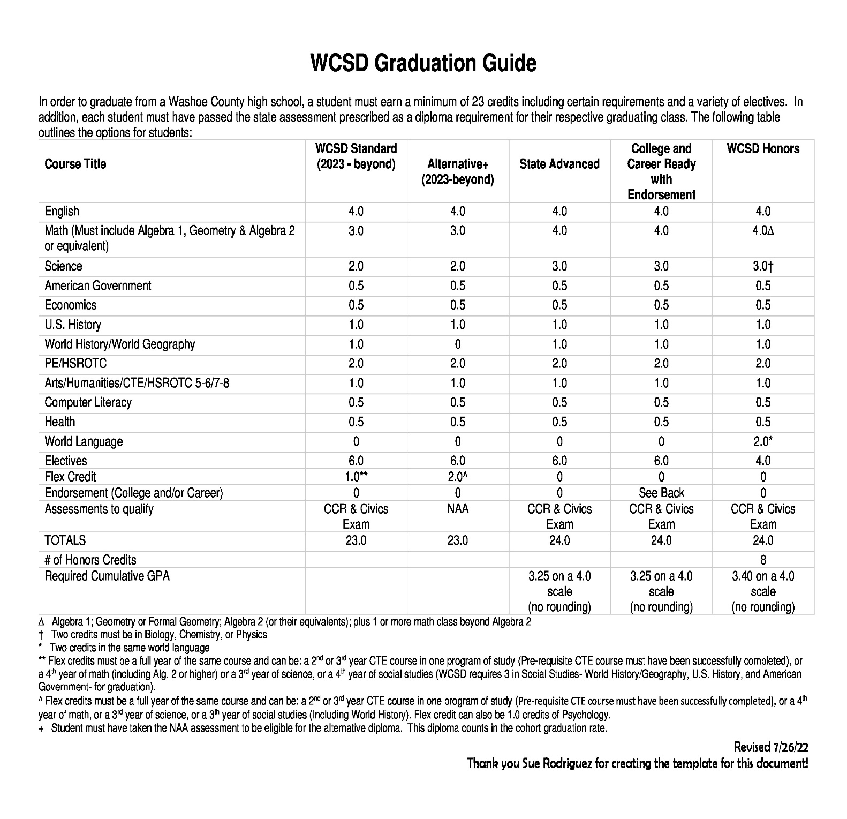

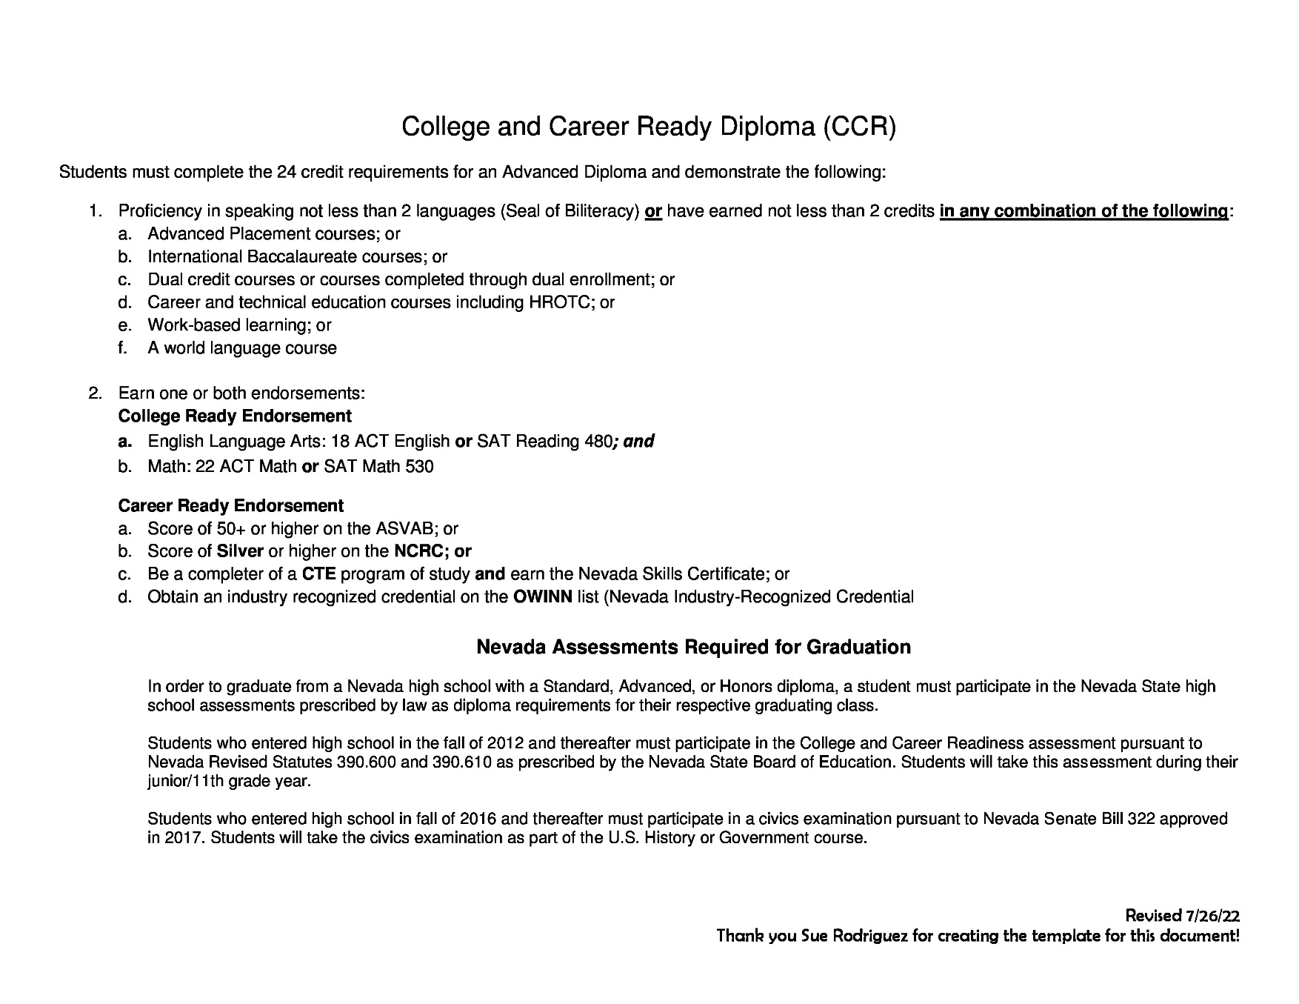
MESSAGES OR EMERGENCIES
Only emergency messages from a parent or guardian will be delivered. Classrooms cannot be disrupted constantly; therefore, messages from employers and friends cannot be delivered.
PARENT COMPLAINT
The Washoe County School District Board of Trustees has established a procedure for receiving and acting on complaints about any employee. The policy requires that the complainant first attempt to settle the issue with the employee in question. If a satisfactory solution not reached, you may pick up a "Public Complaint Form" in the Principal Secretary’s Office. Complete instructions accompany the form. Questions about this policy may be directed to Superintendent of High Schools located at the district office.
SCHOLAR RECORDS—PARENT & SCHOLAR RIGHTS
The Board of Trustees recognizes the rights of scholars who are eighteen years of age or older to inspect their own scholar records. In the case of scholars under eighteen years of age, the Board recognizes the rights of their parents or legal guardians to inspect their children’s scholar records. Further, the Board also recognizes that the privacy of such records shall be protected.
RELEASE OF INFORMATION ABOUT SCHOLARS
Most information about Washoe County School District scholars cannot be made public without consent of parents or guardians. Federal law prohibits schools or the district from releasing information without permission, except for what is termed "directory information." According to the Federal Family Educational Rights and Privacy Act of 1974, directory information about scholars may be released by the district without parental consent, provided annual notification has been given and the school does not have on file written denial to release directory information. However, schools do use discretion when they receive requests for directory information and will not release such information if it is the Principal's judgment that releasing such information would not be in the best interest of the scholar. Directory information is defined as the scholar's name, address, and phone number; scholar's date and place of birth; scholar's course of study; scholar's participation in recognized activities and sports; weight and height of members of athletic teams; dates of attendance; degrees and awards received; and most recent previous school attended. Parents/guardians or scholars 18 years of age or older who do not want any or all categories of directory information released without their prior consent must notify the school Principal in writing by no later than October 1. If no written denial to release directory information without prior consent is received by October 1, the school will assume that consent has been given.
For more detailed information about our WCSD Release of Student Records Policy, please link to: https://www.wcsdpolicy.net/pdf_files/5146%20Reg%20-%20Release%20of%20Students.pdf
TRANSCRIPTS AND RECORDS REQUEST
ALL scholar records requests, special education records requests, background verifications, corporate verifications, corporate information requests, transcript requests, must be made online using our automated scholar record / information request system. Fax, phone calls, email and mail will no longer be accepted. This would include attendance verifications for driver’s permits/licenses.
Please visit: https://washoeschoolsnv.scriborder.com/
VISITOR PASSES
Innovations High School does not issue scholar visitor passes. Adult visitors must sign in and secure a visitor’s pass tag at the main office prior to visiting classes on campus. This includes adult volunteers who enter the building.
For more information about Volunteer Screen and Background Checks Policy, please link to: https://www.wcsdpolicy.net/pdf_files/administrative_regulations/1501_Reg-Volunteers-v1.pdf
For more information about our WCSD Protocols for Visitors on District Property Policy, please link to: https://www.wcsdpolicy.net/pdf_files/administrative_regulations/1506-Reg-Visitors-v3.pdf
TRANSPORTATION OF SCHOLARS
As Innovations High School is not a zone school, there is no transportation provided to our school. Scholars who ride public transportation can receive free bus passes to defray the cost. All Innovations scholars are responsible for their own transportation to and from school daily.
When at Innovations, scholars can be transported in our school van to access learning opportunities beyond our school. When this occurs, school personnel need to inform all parents/guardians of scholars being transported and receive their permission before scholars can ride in the vans.
For more information about our WCSD Transportation Policy, please link to: https://www.wcsdpolicy.net/pdf_files/administrative_regulations/7501_Reg-Transport_of_Students-v9.1_Final.pdf

Innovations High School
Scholar and Staff Compact

As members of Innovations High School, we are all part of a unique learning community in which we all have voice and choice to positively impact others. Our decisions and our actions determine our success and the success of our school.
Staff members at Innovations High School will commit to:
- Cultivating unconditional positive regard for all scholars in our learning community.
- Affirming all scholars for who they are and what they bring to our community.
- Working to grow scholars to be critical thinkers and dynamic change agents in our community and in the greater world.
- Preparing all scholars for post-secondary options that scholars desire.
- Modeling respectful behavior in our school environment.
Scholars at Innovations High School will commit to:
- Attending school at least 85% of all school days.
- Passing at least 80% of your classes to ensure that you are making significant progress towards graduation.
- Practicing kindness and positive citizenship toward other members of our Innovations High School community—both staff and other scholars.
Scholars who are not keeping these three commitments will be counseled to develop a plan to support their success. If there is no growth by the end of the semester, the scholar will be asked to return to their zone school or find an alternative setting to continue their education.
Please note that violations of positive citizenship such as fighting, bullying, theft, possession of controlled substances or harassment of staff or scholars can lead to the immediate removal of a scholar.
Please sign below to enter our Innovations community compact.

Community Member Name: __________________________________________

Community Member Signature:__________________________________ Date: ___________________


Guardian Signature: ___________________________________________ Date:____________________

Innovations High School
Pacto Escolar de Estudiante y Personal

Como miembro de Innovations High School, todos somos parte de una comunidad única de aprendizaje en la cual tenemos voz y voto para impactar a los demás de manera positiva. Nuestras decisiones y acciones determinan nuestros éxitos y así, el éxito de nuestra escuela.
Como miembros del personal de Innovations High School me comprometo a:
- Cultivar una incondicional y positiva consideración hacia todos los estudiantes de nuestra comunidad de aprendizaje.
- Apoyare a todos los estudiantes por quien son y por su aportación a nuestra comunidad.
- Trabajare en el crecimiento de los estudiantes como pensadores críticos y agentes dinámicos de los cambios de nuestra comunidad y del resto del mundo.
- Preparare a los estudiantes para las opciones que decidan después del bachillerato.
- Mostrare un comportamiento respetuoso en nuestro entorno escolar.
Como estudiantes de Innovations High School me comprometo a:
- Asistir a la escuela por lo menos un 85% del total de los días escolares.
- Aprobar por lo menos con un 80% de mis clases para asegurar un progreso significativo hacia mi graduación.
- Practicare amabilidad y seré un ciudadano positivo hacia los demás miembros de nuestra comunidad estudiantil de Innovations High School-ambos, estudiantes y personal.
Los estudiantes que no mantengan estos tres compromisos serán aconsejados para desarrollar un plan de apoyo para que logren el éxito. Si no hubiera un progreso para el final del semestre, el estudiante será dirigido a regresar a su escuela de zona que le corresponde o a una escuela alternativa para continuar con su educación.
Firme a continuación para ingresar a nuestro pacto comunitario de Innovaciones.

Nombre del Miembro de la Comunidad: __________________________________________

Firma del Miembro de la Comunidad:_____________________________ Fecha: ___________________


Firma del Guardian: ___________________________________________ Fecha: ___________________

